**MIND STORM SOFTWARE PVT LTD**

**Android Development Training**

**Hands-On Exercise – ex03 - BuiltInIntents.doc**

**Objective**This exercise shows how to use built in Intents in Android. It means that when we have to perform common operations like dial a phone number, send a SMS, send an email, view a web url in a browser, then there are already existing applications on the Android device that can do it for us. All we need to do then is to specify our intent (what we want to do) and Android will choose the right program and launch it.

**Assumptions**

* Development Environment for Android (Java SDK, Eclipse, Android SDK) has been setup successfully.
* You are familiar with using Eclipse.
* Android SDK 4.x is available and Android Virtual Devices are already created.
* Start the Android Virtual Device to save time.
  + Click on **Window 🡪 Android SDK and AVD Manager**.
  + Select an **Android 4.x** compatible AVD and click on **Start**
  + Select **Scale display to real size** and provide a **Screen Size (in)** as **5 inches** or any other appropriate size for your development machine.

**Step by Step Instructions**

**Step 1 – Create the Android Project**

1. Create a new project. Click on **File🡪New 🡪 Android Application Project**
2. Enter **Project Name or Application Name** as **BuiltInIntentsExercise .**Click on **Next.**
3. Enter **Package Name** as **com.mindstorm.builtinintents .** Click on **Next**
4. Deselect (Uncheck) the **Create custom launcher icon.** Click on **Next.**
5. In **Create Activity**, go with the default options i.e. go with Create Activity and Blank Activity as selected. Click on **Next.**
6. On the **New Blank Activity,** let the Activity Name be **MainActivity** and change the Layout Name to **main**
7. Click on **Finish**
8. (Optional): Verify that the Project runs in your Emulator by **Right-click** the **Project** and **Run As 🡪 Android Application**

**Step 2 – Code the Main Activity**

1. Define the Layout for Main Activity. This will consist of a few buttons which will launch the different applications which correspond to the Intent.

Go to **res/layout** folder. Modify **activity_main.xml** to contain the following (You can simply copy this).

<?xml version="1.0" encoding="utf-8"?>

<LinearLayout xmlns:android="http://schemas.android.com/apk/res/android"

android:layout_width="fill_parent"

android:layout_height="fill_parent"

android:orientation="vertical" >

<TextView

android:id="@+id/textView1"

android:layout_width="fill_parent"

android:layout_height="wrap_content"

android:gravity="center_horizontal"

android:text="Built In Intents"

android:textAppearance="?android:attr/textAppearanceLarge" >

</TextView>

<Button

android:id="@+id/btn_makecalls1"

android:layout_width="fill_parent"

android:layout_height="wrap_content"

android:text="Action Dial" />

<Button

android:id="@+id/btn_makecalls2"

android:layout_width="fill_parent"

android:layout_height="wrap_content"

android:text="Action Call" />

<Button

android:id="@+id/btn_sendsms"

android:layout_width="fill_parent"

android:layout_height="wrap_content"

android:text="Send SMS" />

<Button

android:id="@+id/btn_sendemail"

android:layout_width="fill_parent"

android:layout_height="wrap_content"

android:text="Send Email" />

<Button

android:id="@+id/btn_share"

android:layout_width="fill_parent"

android:layout_height="wrap_content"

android:text="Share" />

</LinearLayout>

1. Go to **src** 🡪 **com.mindstorm.builtinintents** and open **MainActivity.java** file. Modify the MainActivity.java code as shown below:

package com.mindstorm.builtinintents;

import android.app.Activity;

import android.content.Intent;

import android.net.Uri;

import android.os.Bundle;

import android.view.View;

import android.view.View.OnClickListener;

import android.widget.Button;

public class MainActivity extends Activity {

Button b1, b2, b3, b4, b5;

/** Called when the activity is first created. */

@Override

public void onCreate(Bundle savedInstanceState) {

super.onCreate(savedInstanceState);

setContentView(R.layout.activity_main);

// ---Action Dial button---

b1 = (Button) findViewById(R.id.btn_makecalls1);

b1.setOnClickListener(new OnClickListener() {

public void onClick(View arg0) {

Intent i = new Intent(android.content.Intent.ACTION_DIAL, Uri

.parse("tel:+651234567"));

startActivity(i);

}

});

// ---Action Call button

b2 = (Button) findViewById(R.id.btn_makecalls2);

b2.setOnClickListener(new OnClickListener() {

public void onClick(View arg0) {

Intent i = new Intent(android.content.Intent.ACTION_CALL, Uri

.parse("tel:+651234567"));

startActivity(i);

}

});

// ---Send SMS button

b3 = (Button) findViewById(R.id.btn_sendsms);

b3.setOnClickListener(new OnClickListener() {

public void onClick(View arg0) {

Intent i = new Intent(android.content.Intent.ACTION_VIEW);

i.putExtra("address", "9820300784;9821060381");

i.putExtra("sms_body",

"Hi. I am currently attending the Android Workshop.");

i.setType("vnd.android-dir/mms-sms");

startActivity(i);

}

});

// ---Send Email button

b4 = (Button) findViewById(R.id.btn_sendemail);

b4.setOnClickListener(new OnClickListener() {

public void onClick(View arg0) {

Intent emailIntent = new Intent(Intent.ACTION_SEND);

String[] to = { "romin.k.irani@gmail.com",

"romin.irani@mindstormsoftware.com" };

emailIntent.putExtra(Intent.EXTRA_EMAIL, to);

// String[] cc = carbonCopies;

// emailIntent.putExtra(Intent.EXTRA_CC, cc);

emailIntent.putExtra(Intent.EXTRA_SUBJECT,

"Reminder For Android Workshop");

emailIntent.setType("text/plain");

emailIntent

.putExtra(

Intent.EXTRA_TEXT,

"Please note that the Android Workshop is going to be held on 23rd March 2013.");

startActivity(Intent.createChooser(emailIntent,

"Send Email via..."));

}

});

// ---Share button

b5 = (Button) findViewById(R.id.btn_share);

b5.setOnClickListener(new OnClickListener() {

public void onClick(View arg0) {

Intent sharingIntent = new Intent(android.content.Intent.ACTION_SEND);

sharingIntent.setType("text/plain");

String shareBody = "The Android Workshop is being held right now. Please rush !";

sharingIntent.putExtra(android.content.Intent.EXTRA_SUBJECT, "Android Workshop");

sharingIntent.putExtra(android.content.Intent.EXTRA_TEXT, shareBody);

startActivity(Intent.createChooser(sharingIntent,

"Share Content via..."));

}

});

}

}

**Step 3 – Add the Permission in Manifest**

Go to the **AndroidManifest.xml** file and add the following permission. This is needed when you use the **ACTION_CALL**. Add this element as a child of the **<manifest>** element and outside of the **<application>** element (Just above it).

<uses-permission android:name="android.permission.CALL_PHONE"></uses-permission>

**Step 4 – Run the Example**

1. **Right Click** the **Project** in Eclipse.
2. Select **Run As 🡪 Android** Application
3. (Optional): If you have multiple compatible AVDs running, select the correct AVD. In our case it is the 4.x AVD.

You should see the MainActivity screen come up.

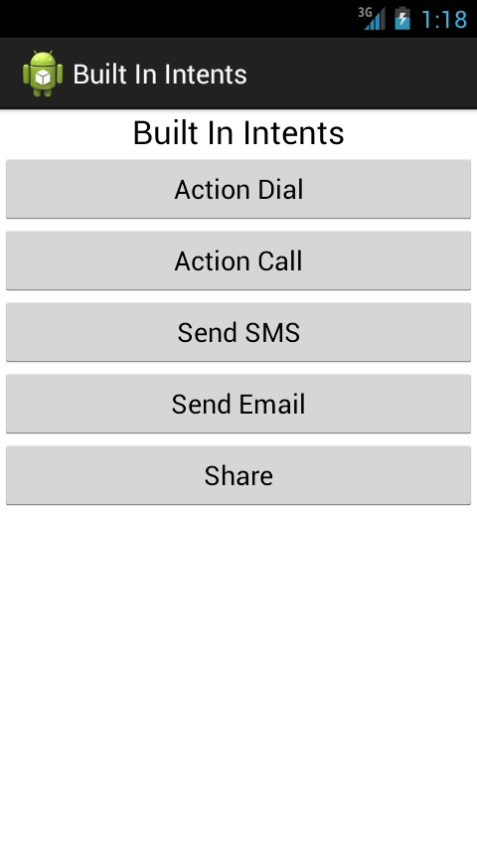

Clicking on any of the buttons will result in the application specifying an Intent where it only specifies the Intent Action along with data. For e.g. if you click the Make Calls button, it will launch the Call Application as shown below:

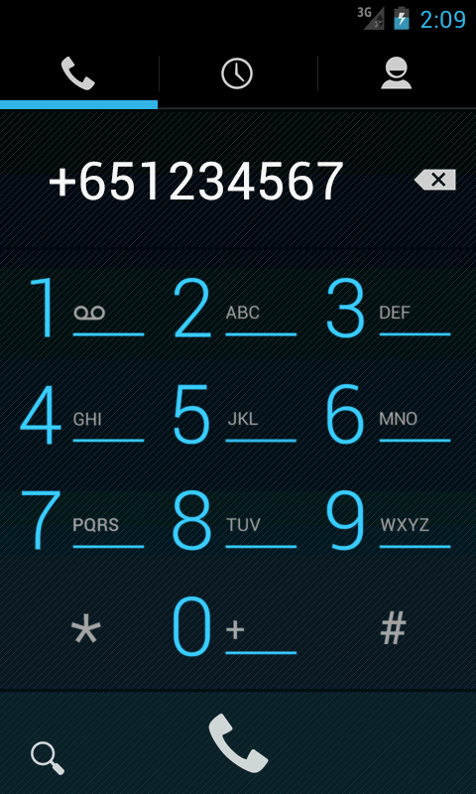

**Summary**

This hands-on exercise demonstrated how to use Built-In Intents in Android. We learnt about the following built-in intents in Android:

* android.content.Intent.ACTION_DIAL
* android.content.Intent.ACTION_CALL
* android.content.Intent.ACTION_VIEW
* android.content.Intent.ACTION_SEND

More Reference:

1. For built in Intents of Google Applications : <http://developer.android.com/guide/appendix/g-app-intents.html>
2. For more Actions available in Android : <http://developer.android.com/guide/topics/intents/intents-filters.html>